LAB 3: Multi Provider

Q-1 Can we use multiple providers in the same configuration directory?
A-1 Yes

Q-2 We have a new configuration directory located at the path /root/terraform-projects/multi-provider. Inspect this directory and find out the number of providers initialized.
Don't run the terraform init command yet!
A-2 We Don’t run terrafom init . So, 0 providers initialized.
terrafom init will initialized terraform and look into main.tf file for provider. Depend upon provider , it will download and install plugins and provider.

Q-3 Go to working directory and run terrafom init. Count how many plugins installed in woking directory ?
A-3 2 – 1 is local, 2 – random
Q-5 Now, Navigate to the directory /root/terraform-projects/MPL. Create a new configuration file called pet-name.tf.
This file should make use of the local_file and random_pet resource type with the below requirements:
local_file resource detail:-
Resource name = “my-pet” , File name = “/root/pet-name” , Content = “My pet is called finnegan ! !”

random_pet resource detail:-
Resource name = “other-pet” , Length = “1” , Prefix = “Mr” , Separator = “.”
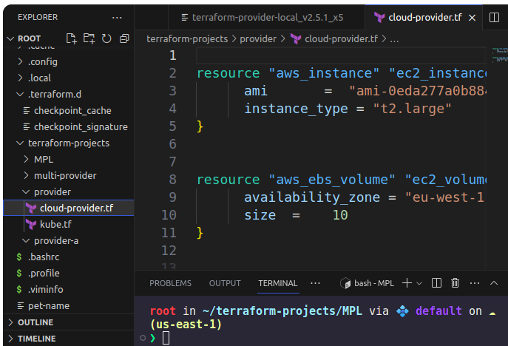
Once the configuration file has been created, use the terraform workflow to create this resource.
Q-6 Now change into the directory /root/terraform-projects/provider and inspect the file cloud-provider.tf.
What is the instance_type configured with the resource type called aws_instance?
Don't worry if you are not familiar with the aws providers. We will cover it later on.
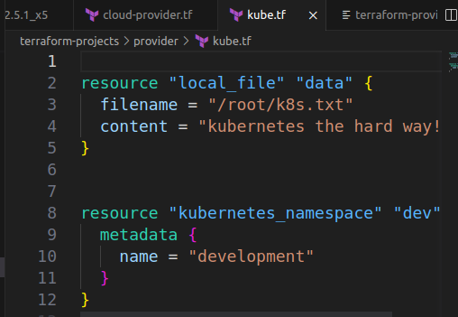
A-6 t2.large
Q-7 What is the name of the resource configured with the resource type kubernetes_namespace in kube.tf file within the same directory?
A-7 dev

Q-8 Let's get some more practice! Now navigate to the directory path /root/terraform-projects/provider-a. Create a configuration file called code.tf.
Using the local_file resource type, write the resource block with the below requirements into the file:
Resource name = iac_code
File name = /opt/practice
Content = Setting up infrastructure as code
When ready, only run the terraform init command, we will run the terraform apply command later on.

